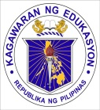
Republic of the Philippines
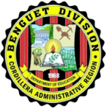
Department of Education
Cordillera Administrative Region
Schools Division Office of Benguet
Kabayan District
KABAYAN CENTRAL SCHOOL
Poblacion, Kabayan, Benguet

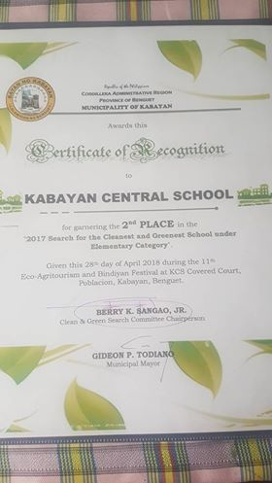
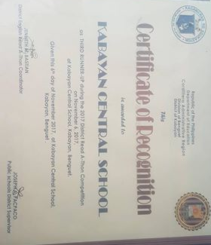
CERTIFICATES

